A Study on
The Life of David

Table of Contents:

1) Introduction to the Life of David the Man, Samuel, and Chronicles 2

2) Introduction to David the Figure, Type of Christ 5

3) David’s Anointing 8

4) David and Goliath 10

5) David’s Friendship with Jonathan 13

6) David Protected from Saul 16

7) Nabal and Abigail 21

8) Saul’s Downfall and David’s Interaction with the Messenger 24

9) David Reigns at Hebron/Jerusalem - Emphasizing his glory 27

10) David and Bathsheba - Emphasis on the sinner 31

11) Overview of David’s Reign 33

12) The Downfall of David’s Family, Prophecies Fulfilled, Census 37

13) David Prepares Solomon to Build the Temple, David’s Death 40

Appendix A - Saul’s Family Tree 41

Appendix B - David’s Family Tree 42

Appendix C - Maps of David’s Movements 45

Appendix D - Character Reviews 49

Appendix E - Timeline of David’s Life 52

Appendix F - List of Other Ref to David in OT and NT 53

Bibliography 54

Lesson 1

Introduction to the Life of David the Man, Samuel and Chronicles

David, a man after God’s own heart, the recipient of the everlasting royal promises, shepherd, loyal friend, slayer of giants, musician, composer, king of Judah, ancestor of Jesus. On these titles alone, he deserves a place in our memory and study. But David was a complicated man. He was also a liar, a polygamist, a refugee, a man of blood, a weak-handed father, an adulterer and a murderer. More chapters of the Bible are devoted to the life of David than Abraham, Isaac, Jacob, and Joseph combined. Only Christ has more written about him. David is first referenced in the genealogy of Ruth, but he first appears in the narrative of the Bible in 1 Samuel 16 where he is found in every subsequent chapter except 31. He is the primary character of all of 2 Samuel and of chapters 11-29 of 1 Chronicles. He and his family are also mentioned in 2 Chr. 2-3. 1 Kings 1-2 also record the events of the end of David’s life. In total, 57 chapters are devoted to the life of David. Additionally, there are over 50 references to David, David’s house, or David’s throne in the prophets and writings: and 76 Psalms are attributed to him. The task of studying David’s life, therefore, is both herculean and imperative.
It is important to note, before we begin, that no good writer ever writes with the sole intention of simply preserving facts. Every writer has a purpose for their writing and the author(s) of Samuel-Kings and the author(s) of Chronicles are no different. While this study does take a chronological path through the life of David, it is important to realize that the different authors include David for different purposes as he fits the message they are trying to convey and we as the readers are left seeing the parts of David that these writers wished to preserve.
The books of Samuel and Kings were written as one big history book with the primary purpose of explaining why God’s people had to go into captivity. Manasseh carries the main weight of the accusation of wickedness, but he does not carry the guilt alone. Of the 42 kings in Israel and Judah, only 9 are good. Of those 9 good kings, none of them are truly very virtuous or without fault. David sins with Bathsheba (among other things), Asa locks up the man of God and dies of a horrible disease because of it, Jehoshaphat foolishly aligns himself with Ahab, and Joash turns from the Lord after Jehoiada dies. Additionally, Amaziah worships the Edomite gods he has just defeated, Uzziah tries to be a priest and contracts leprosy, and Jotham fails to remove the high places. Furthermore, Hezekiah appeals to the Babylonians instead of to God and thus incurs judgement for the nation, and Josiah dies fighting the Egyptians against God’s commandment. The message is clear. All have sinned and fallen short of the glory of God. Every king was flawed, even the good ones, and that is why the people had to go to captivity. David’s role in this narrative is not as a royal king, but as a sinful man. No matter how much good he did, he too deserved exile because he was a sinner in desperate need of God.
Chronicles was written after the exile with the primary purpose of showing how to return to God and what to do now. It has two main themes, the temple and the king type. Its theme verse is 2 Chronicles 7:14 “If my people who are called by my name humble themselves, and pray and seek my face and turn from their wicked ways, then I will hear from heaven and will forgive their sin and heal their land.” The whole book of Chronicles features kings seeking or not seeking God’s face. The king that most closely aligns with this pattern and purpose is Manasseh. In 2 Chronicles 33:12-13 we read “And when he (Manasseh) was in distress, he entreated the favor of the Lord his God and humbled himself greatly before the God of his fathers. He prayed to him, and God was moved by his entreaty and heard his plea and brought him again to Jerusalem into his kingdom. Then Manasseh knew that the Lord was God.”
Chronicles is a picture of humble return to God and leaving the old ways. Through what means did they seek God? Certainly in prayer, but also at the temple. The temple is where God dwelt and consequently, the Levites and the temple feature much more prominently in Chronicles than in Samuel and Kings. Compare, for example, 2 Samuel 6 and 1 Chronicles 15. Both tell the same story, but Chronicles features the Levites much more prominently. This is true throughout the narrative. The other important theme of Chronicles, the king type, is where we find David. The Chronicler, based on all the prophets for the last 300 years, knows that a new king is coming who will be better than any king that has ruled before and who will sit on the throne of His father David. With that in mind, the Chronicler chose to portray David as the fullness of kingly splendor. He is not the king to come, but a good enough picture that his readers will look with hope for the coming king. For that reason, Chronicles does not include David running from Saul, David in danger, David losing, David sinning with Bathsheba or lying to the priests or running around in Philistia like a madman. There is no contest to his throne from Ish-bosheth or Absalom. There is no mention of domestic problems, Joab usurping the king’s authority, or anything that would portray David in any light except royal and kingly. There is only one exception to this rule, which is that David is recorded as taking the census, but the reason for this is clear from examining the first point of emphasis in Chronicles. After the census, David offers a sacrifice near Mount Moriah, the site of the future temple. In conclusion, David’s role in Chronicles is to point to a glorious coming king who we know to be Christ.
Our intent in studying this material is to go beyond the famous stories of David and Goliath, and Bathsheba and delve into a deeper discussion of lessons to be learned from the details. For example David was known for inquiring of God often when help with a decision was needed. The process of how this occurred with the Urim and Thummim with the priests’ help is interesting in and of itself, also to note what happens when it was abandoned and Saul went to inquire through other means (Medium at Endor). It is interesting to note that at times when God was delivering David, He actually answered with multiple outcomes to a situation pointing to God’s Omniscience or all-knowing quality. One of these occasions is noticed in 1 Sam 23 when David saves the city of Keilah from the Philistines.
There is a lot of value in the character studies in these books. For this reason, we will have reviews on these characters in Appendix D.
There are also many underlying themes to notice and discuss. When you compare the strength of the Israelites as a nation, there is a stark contrast between how their corrupt leadership under the priests kept them loosely organized so that they could barely keep their enemies away. On the contrary, by the end of 2 Samuel, Israel under God’s leadership through David had become “the most powerful kingdom in the eastern Mediterranean region, strong at home and secure abroad.” (Longman III and Garland, 31).
One theme to note is the significance of the Ark of God throughout the narratives. There was no image of the God of Israel, instead they had the Ark of God. Yet, God refused to be manipulated by their use of the ark. Just because they carried it into battle did not guarantee them a victory (1 Sam.4:3-11). The Philistines learned that it couldn’t be treated like an idol and that just placing it in their temple did not automatically guarantee them a divine blessing. This helps us understand, though why retrieving the ark was important to David, it belonged with God’s people. It reminded them about God’s expectations for their lives.
One last theme of 1 Samuel focuses on the reversal of human fortune. In other words, “human fate is reversed by God’s will occurring in the lives of Hannah, Samuel, Saul, David, and Solomon.
When you consider the reversal of fortune in David’s life, (Tsumura, 69) he was the youngest but was chosen instead of his seven brothers (1 Sam. 16:1-13). David was inferior in rank to Jonathan, however Jonathan states that he was inferior to David. The Spirit of the Lord departed from Saul and was poured on David. It seems that this backdrop of transitions from Eli to Samuel as Judge and Saul’s transitional reign to David’s heightened reign and Solomon’s thereafter helps us to understand the providence of God guiding and controlling events to bring about his will.
With that in mind then, we can examine the highs and lows of David’s life in context with the books that record them. David is a glorious reminder of the Christ who is enthroned in Heaven, but he is also a very flawed human being, just like us, who needs God’s grace and mercy. Our emphasis must be properly placed not on an exalted likeness of David to Yahweh, but on the sovereign will of Yahweh who chose David as the instrument of His purpose (Gordon, 49, 2 Chronicles 34:3).
God gave David the time necessary to mature into the role of king that God needed him to be. It is said of David in Acts 13:22 that God had found “David the son of Jesse, a man after His heart, who would do all His will.” This could mean that David was a person whose desire was to search out God’s will and God’s heart. It could also mean a person who has a heart that God looks at with favor. It could be a combination of both of these character traits. It is also said of David in Acts 13:36 that “David, after he had served the purpose of God in his own generation, fell asleep.” Wouldn’t both of these descriptions be something we would want to be said of us? It would be a good goal for us all to be able to attain the level of maturity that we could seek out God’s will, to follow Him alone, find our purposes and fulfill them, thus glorifying God in our own generation.
Many valuable lessons can be learned from both of these lenses on David, so please read on as we study David: The Man and King. Quotes were taken from the ESV.

Discussion Questions:

- What are your goals as we start this study of the Life of David through Samuel and Chronicles?

- Find some sources that indicate the possible dates of writing for Samuel, Kings and Chronicles. Why is this significant?

- What are some themes and applications that interest you in the books of Samuel, Kings, and Chronicles?
Lesson 2
Introduction to David the Figure, Type of Christ
1 Chronicles 12:38-40

We have looked at David the man and yet if you look beneath the facts and events going on in his life, you will find a much deeper meaning and message going on and expressed.
We have already mentioned some of the underlying themes found in Samuel, Kings, and Chronicles. First and foremost, God is immensely powerful beyond what mankind can imagine or attribute to their man-made images. He is controlling history. God demands exclusive worship and true wisdom is defined in terms of true worship and wholehearted obedience. David exemplifies seeking true worship and allowing God to transform him from a sinner to a reflection of the image of God.
God made promises to our fathers: Abraham, Isaac, and Jacob. Yet God’s justice requires execution of judgment upon the wrongdoers. At times sin marred the nation to such an extent that judgement fell upon whole cultures affecting the innocent as well as the guilty. Yet God was gracious and merciful towards his people. In addition to the earlier promises, He promised David an eternal kingdom (2 Sam. 7). The subsequent kings are often compared to David and whether or not they walked in the way of the Lord.
We often say that David was a type of Christ, but what does this really mean? A type is like a hint or foreshadow. A person who is a type is like a symbol of something to come in the future. It can be a character that has a small amount of a trait; yet there’s a future character that perfects that quality. The purpose of studying a type is to give us deeper meanings to help us understand the scriptures. Another reason that we study types of Christ (there are many) is that while we are striving to be close to Jesus, our fleshly sins sometimes cause us to feel distant from him. Consider the way a “type” is used in Deuteronomy 18:15-16. The people had asked Moses to be their intercessor at Mt. Horeb, because they were too afraid to hear God’s voice. Moses said at a later date, that the Lord would raise up a prophet like Moses who would speak in the name of the Lord. This points to raising up David in the short-term, however Christ is The Prophet, the full perfection of all that God had planned for his people. In John 1:17, It says, “For the Law was given through Moses; grace and truth were realized through Jesus Christ.” Also, in verse 21, John said he was asked by the priests and Levites if he was “the Christ, Elijah, or The Prophet.”
They were looking for the prophet that was spoken of in this verse from Deut. 18:15.
When we identify with the imperfect characters (types) pointing to Christ, it is then that we realize how God can take imperfect people such as ourselves and extend His mercy and grace to find a value and worth to use us as vessels for His will for mankind. Consider just a few of the characters that were considered types of Christ.

Prophets: Elijah, Moses, Zechariah
Priests: Melchizedek, Aaron, Samuel
Kings: David, Solomon, Hezekiah, Josiah

In this study we will focus on how God chose to portray David in detail as a type of Christ. David was chosen as the good king, the man after God's own heart. The one to return to Him over and over despite his mistakes. As humble and repentant as David was, he was a man far from perfection. Yet, David is still idealized as a glorious king who will care for his people and shepherd God’s flock and rule with justice and with power. Moreover, David is represented as a type to Christ in many ways. He came from a humble beginning, a shepherd and keeper of his sheep. David was from Bethlehem (1 Sam. 17:15, Micah 5:2, Matthew 2:5). He was specifically chosen and anointed to complete God’s purpose for Israel. Neither Christ nor David were respected at first for their lowly beginnings (1 Samuel 22:7; Matt. 13:55-56). Their own siblings doubted and did not support them in the beginning. (1 Sam. 17:28; John 7:5).
David had the spirit of God and was called a prophet (Acts 2:29-36). He was loved by God and the people of his kingdom. They were both exalted to higher places of honor than their earthly beginnings. However, David could not maintain the honor due to the consequences of his sin; thereby pointing the way to the future Messiah and perfect king. They both subjected their actions to the will of the Father and acted on His timeframe.
When Israel asked for a King and God told Samuel that they had not rejected him but they had actually rejected God (1 Sam. 8:7), there are some interesting points to consider. God had planned all along for there to be a physical King over his nation and had prepared the people for that (Gen. 17:6, 49:8, Judges 1:1-21, 20:18). However, God wanted to be King over the appointed king. When they asked for a king, they wanted one, “like all the other nations, one who would go out and fight their battles,” yet they forgot that it was God who was leading them in battle (Deut. 20). They had replaced God with the idea of glorifying and relying on their own king. Consider the qualifications that God had for an earthly king in Deuteronomy 17:14-20. Their king was to be a humble shepherd and protector of his people. He was to be very knowledgeable in the law since he was to have written it all out during his reign. (This reminds us of how our Elders lead in the church today). Most importantly, David understood that his rule had no validity apart from the rule of God, which is why he does not usurp his kingship after first being anointed until the timing was right. He understood that he was only executing God’s rule in Israel. The kings following David are compared to him in how well they understood their actual place on the throne and to follow God’s plan.
How did David actually do in succeeding as a King according to the Deuteronomy qualifications? He was chosen from God, from among his countrymen, David was definitely well-connected with God, leading the people to turn to God. David didn’t turn to another nation like Egypt for leadership and assistance, he looked to God with Samuel’s guidance. He trusted God’s counsel in battle and knew God would guide him.
Some of David’s failures involved multiple wives, wealth, power, and even horses. He also accumulated and trusted in his own power which was evident at the end of his reign during the time of the census in 2 Sam. 24.
In considering Jesus, He is called the son of Jesse instead of the son of Joseph several times (Isaiah 11:1). He is also called the son of David, the one who would fulfill messianic hope and re-establish the lineage of the Davidic line through Judah through both Joseph and Mary’s lines (Rom. 1:3, Hebrews 1:5, 2 Corinthians 6:18). There are many passages seen throughout the minor prophets that there was a remnant remaining of God’s protected and chosen people and glimmers of hope for the future when God would establish the perfect Messiah and King to rule his nations forever (Jer. 30:9; Hos. 3:4-5; Ezek. 34:23-24, ,Jeremiah 23:1-5, Micah 5:2). Consider the implications of a few passages in depth.
In Isaiah 11, we are told of the shoot that would spring forth from the stem of Jesse. This passage describes David as the type of Christ. In verse 2, the Spirit of God was in him to help him judge rightly. Solomon also continues this idea of fulfilling the kingship on earth. In New Testament times, the religious leaders of the day knew that the house of the United Kingdom was dead, a stump that had been cut down. They knew the promise that something much more glorious was coming. The prophets had been telling of a kingdom where all people would come together, an ideal place. Jesus doesn’t fit their idyllic dreams of the big prophet they were promised. This passage isn’t about what people thought David was, but what David could be.
This brings to question, “Who is the shoot?” Hezekiah, Josiah? No, it’s Jesus the Christ. In all of his superiority as a prophet, High Priest and our everlasting king, Jesus is the true manifestation of the perfect one found to rule on God’s throne over His people. He was the only one worthy and all glory goes to Him.
In addition, the Jews had an idea about the end of the age (Isaiah 2, 9, Micah 5, Zechariah 14). It would be a kingdom wholly devoted to God, its powerful and mighty and lives in a time of peace and prosperity. Israel’s enemies would be put down while Israel is raised above everyone else. This prophetic future is led by a king that is perfect and kind, who brings peace and love and justice to the poor. All of this is the messianic prophecy of David. This is what people expect when they talk about one coming who is like David. This is what the apostles expected when Jesus said the kingdom of heaven was at hand. The Jews expected the one that came to bring power and holiness. They also expected Him to restore the fortunes of Judah, to establish justice and righteousness forever. All of these ideas are connected and rolled together into the expectations of the messiah. It’s not just that David was a good king, but that he stood for God, he brought the blessings of God, he turned the people to God, he struck down God’s enemies. These are the ideas that made David a type of Christ.

Discussion Questions:

- What is a type? Name 2 characters that were types of Christ and a brief explanation of how they exhibited those traits.

- Pick one of the passages from the prophets and consider how it related to David and to Christ.

- How had the people of Israel rejected God?

4) How can we as individuals and also collectively as a church reject God today?

5) Read Isa 2:1-4, Isa. 9:6-7, Micah 5:2,7-9, Zech 14:16-21 What does each say about “Jewish Heaven,” or put more plainly, the Jewish expectation of the end of the age? Who rules this kingdom? Is it peaceful? Do they follow God? What about Israel’s enemies? Is it just Jews or many nations?

6) What lessons can we learn on how we can maintain our hope of Salvation as imperfect people?

Lesson 3
David’s Anointing
1 Samuel 16

In this chapter, God told Samuel that He had rejected Saul from being King over Israel. God was sorry that He had made Saul King because He did not carry out God’s instructions. Saul had not waited for Samuel and had made a sacrifice himself after the battle of the Ammonites in 1 Samuel 13: 1-22. After the hasty sacrifice, Samuel had told Saul that “The Lord has sought out for Himself a man after His own heart, and the Lord has appointed him as ruler over His people” (1 Samuel 13:14). In addition, Saul did not utterly destroy the Amalekites as commanded by God and lied and said it was the people’s fault in 1 Samuel 15:1-35. Samuel told Saul that it was better to obey God than to sacrifice because insubordination is sin and idolatry. He was told that because he had rejected the word of the Lord, God had also rejected Saul from being king (1 Samuel 15:22-23). While Saul attempted to ask for forgiveness and to acknowledge his sin in listening to the people rather than to God, Samuel told him it was too late, because God’s plan was already in action to replace Saul.
Samuel feared Saul’s reaction if he heard he was on his way to anoint the new king. God gave him a purpose in his travels. He was to take a heifer and say, “I have come to sacrifice to Jehovah.” God furthermore gave Samuel instructions to “Not look at his appearance or at the height of his stature, because I have rejected him; for God sees not as man sees, for man looks at the outward appearance, but the Lord looks at the heart” (1 Samuel 16: 7).
According to God’s instructions, after passing over David’s seven older brothers, Samuel had Jesse call David in from the field and anointed him to be the new King. Anointing may have involved a similar action as had been done to Saul in 1 Samuel 10:1 where Samuel took a flask of oil, poured it on his head, kissed him and said, “Has not the Lord anointed you a ruler over His inheritance?” This process is only mentioned one other time for a king in 2 Kings 9:1-3 for king Jehu. However there is one big difference. Samuel never said that he was anointing David as King at this time.” Samuel may have been the only person who knew what this private anointing really meant. Perhaps the Spirit of the Lord revealed it to David and his family may have not even known about it. There were other reasons that people and objects were anointed by oil in the Bible.
David was described initially as “One who was ruddy, with beautiful eyes and a handsome appearance” (v. 12). This is not the tall, head and shoulders description of their first king. Here we start to see the theme that “Victory is found in humility.” Some time passed and later when Saul looked for help in his court, David was described here as one who was found to be “skillful in playing an instrument, a man of valor, a man of war, prudent in speech, a man of good presence” (v.18). Most importantly, the Lord was with this youngest son of Jesse. In the next chapter, he was called a youth or a young man, by Saul, emphasizing David had little experience. However, David was not a mere child, a “little boy” that we sometimes sing about in childrens’ classes. While God was with David during these animal encounters, it is more likely an older youth would have been able to kill a lion and a bear and in a short time period, needed to be tall enough to wear a man’s robe (1 Sam. 18:4) (See the Timeline in Appendix E). In the latter part of this chapter, Saul brought David into his service where he is able to calm Saul from the evil spirit. Saul was to continue as king as long as he lived, but his sons would not be allowed to reign after him.

Discussion Questions:

1) Samuel traveled about ten miles from ________ to __________ to the home

of _____________ the _____________to anoint _______. 1 Sam. 15:34, 1 Sam. 16:1. What did he bring with him? ____________________Why did the city elders receive Samuel with trembling?

2) What secondary reason did the Lord provide Samuel to travel to Bethlehem?

3) What is the contrast between God and Man’s ways of seeing? 1 Sam. 16:7 Give some thought to how you have personally changed your mind about a situation later after consideration of a more spiritual outlook.

4) How many times was David Anointed? How is the narrative different in 1 Chron.11:1-3?

5) What is the significance of the Spirit of the Lord coming upon David in vs. 13-14?

6) Looking at the phrase “man of war” (a trained fighter) in vs. 18, why do you think David is described this way when he is still a shepherd? How much later do you think this happens?

7) What other places in the Bible does the Lord send an evil spirit or powerful delusion?

Lesson 4
David and Goliath
1 Samuel 17, Psalm 23

In this very famous story, we find David first being sent with provisions for his three older brothers at the battle. God first introduces the geography of the two mountain camps and landscape of the battle and then tells the story because it was important to understanding the outcome. Whoever controlled the valley had a powerful advantage. For a great visual perspective of the Valley of Elah and other pertinent information to these events, please consider watching: “Israel’s United Kingdom: The complete Series (especially episode 2) by Appian Media on YouTube. David hears Goliath taunting the Israelites as he had for forty days and reveals a Godly indignation. This results in his verbal exchange with Saul regarding the armor and his confrontation with the giant. Goliath must have had a very intimidating presence simply by the description of the size of his armor. The Septuagint (Greek)records Goliath as being 6:9 instead of 9:9 (Hebrew text) We don’t really know how tall he was but can guess his strength by his sword and armor. Goliath’s armor (coat of mail) weighed 125 pounds and was made out of bronze. He also carried a sword and a javelin with a spearhead weighing 15 pounds, and wore a bronze helmet. He had a shieldbearer who went before him. Note the adjectives as you read this passage and how they describe Goliath’s slow motions and David’s quick ones.
David is not discouraged by Goliath’s size, Saul’s doubt, or his brother’s accusations. He went down into the valley and chose his stones out of the brook. Goliath grew up near this area and he knew the area well. When it came time, David ran towards Goliath and his shield-bearer unafraid. With confidence in God, he took down Goliath in one shot and cut off his head with Goliath’s sword. Then the men of Israel and Judah arose and pursued the Philistines to the gates of Ekron.
God once again chooses to use a simple and unexpected means to defeat Goliath and the Philistines; reminding everyone of His power to deliver and protect given our trust. It is interesting to note that Saul’s tribe of Benjamin were well-known for using the slingshot with mastery (There were seven hundred left-handed Benjaminte slingers, “each of whom could sling a stone at a hair and not miss.” Judges 20:16). Saul should have been the one out in front defending the nation. The fact that David used a slingshot and the stones began to show how God was intending to replace Saul. Also, Saul stood head and shoulders above the rest, and would have actually been the best match and should have been motivated to fight Goliath, but like his troops, was paralyzed with fear. David gave God the glory for the defeat and was also eventually rewarded handsomely by Saul (free taxes for his father and eventually given Michal as a wife). Again we see the theme of “Victory is found in humility.”
David had already been serving as one of Saul’s armor-bearers. Soon, he would be placed in a high-ranking position in the army and allowed to fight against the Philistines.
At times we are called to do tasks in the face of criticism and doubt. David received a lot of criticism from his older brothers, yet it was evident that he wasn’t confident in himself, he was confident in God’s ability to deliver him. David was supremely confident in God and said “The battle is the Lord’s.” David wasn’t fighting for himself, he was upset at the reproach being brought on the nation of Israel. He fought for the good of the people and didn’t care what people thought about him in the process. He pointed the army in view towards God.

Discussion Questions:

- Describe David and Saul’s relationship at this time.

- How is David’s confidence described throughout this chapter?

3)How is David starting to view the world like God does?

4) Why was Eliab so upset in V28?

5) What do you think David’s motivations were to challenge Goliath?

6) Why did David choose 5 stones?

7) What is the importance of giving God the glory in our lives?

8) Find some other examples or commands to put our trust in God when we are in a difficult place.

9) What is the significance of David taking the head of Goliath to Jerusalem in vs. 54? Is there any reason why this wouldn’t make sense in the narrative? Can you explain this

10) What is our present day responsibility to stand up for the name of God?

Thought question: Do you think David’s defeat of the lion and the bear was miraculous?

Lesson 5
David’s Friendship with Jonathan
1 Sam. 18

Jonathan, David, Michal

After slaying Goliath, Saul would not let David return to his Father’s house. Immediately, Saul’s son, Jonathan and David became close-knit with a special bond, even though it is probable that Jonathan was a lot older than David, by at least ten, possibly twenty-five years. Their friendship and relationship was described as being unified, “one in spirit,” and having exceptional commitment, “he loved him as himself” (v. 1-3). Jonathan recognized that David was a special person, chosen by God. He honored David and so did the people. David received respect wherever he went from the people, but not Saul. Jonathan made a covenant of friendship with David. He gave him extravagant gifts including: his own tunic, sword, bow, belt, and most importantly his princely robe. When it became more evident to Jonathan that David would take his rightful place on the throne rather than himself as the prince, he deferred to God’s will instead of showing resentment. Jonathan would prove to be a loyal friend many times.
David was so successful that Saul set him over the men of war (the army). David achieved instant popularity and success. He became a hero in all of Israel. It was said of him by the women, “Saul has slain his thousands, and David his ten thousands”(v.7). Soon, the people praised David more than Saul and his anger and jealousy was incited against David. Saul attempted to kill David twice and was afraid of David because the Lord was with him, but had departed from him (v.12).
Saul attempted to give David his elder daughter Merab as a wife but he protested, saying, “Who am I, and what is my life or my father’s family in Israel? I am not worthy to be the king’s son-in-law.” So Merab was given to a man named Adriel and they would suffer great loss with their children (2 Samuel 21:8-9). This was all part of a plan by Saul to endanger David in battle with the Philistines again (v.17). Later David was encouraged to again become the king’s son-in-law and be given Michal, who loved him, however this plan did not come without ulterior motives. David still insisted that he was still a poor man and of little esteem. Saul tried to trick David into being killed by requiring proof that 100 Philistines had been slain. David safely brought back twice that and was still protected and safe. Saul’s fears increased. There is a lot of contrast in the ways the people viewed David and Saul’s growing hatred and jealousy towards him. The text says that “Saul was David’s enemy continually”(v.29). There is also a contrast in how the Spirit of the Lord is with David, and an evil spirit is tormenting Saul. This plays into the next ten years as we see the rise of David and the fall of Saul.
When David struggled with his enemies, he put his trust in God. God provided protection and loyal friends to support David as his life became endangered multiple times. God was truly a shield about him (Ps. 3:1-3). It is ironic that David would not have raised a hand against the Lord’s anointed, yet Saul’s paranoia had exceeded the point where he could imagine David as a loyal subject and only viewed him as a threat. The more Saul tried to entrap David, the more his plans backfired and he caused more opportunities for success instead. This principle of reverse returns is seen throughout the Bible (Joseph, Daniel and his friends in Babylon). When we experience trials from our enemies, do we see them as an opportunity to glorify God and to grow stronger in our faith and trust in God as these Bible characters did?

Discussion Questions:

- Both Saul and David had a wife named Ahinoam, but she wasn’t the same person. Who was she? Who was Saul’s concubine? 1 Sam.14:50, 1 Sam. 25:43

Refer to Appendix A and B for the family trees of Saul and David (1 Chron. 3:1-9).

Research Verses about David’s Wives:

- Why was David so successful?

- Describe David and Jonathan’s relationship? What is the significance of Jonathan giving David his robe and belt?

- Why did David reject Merab? To whom did she marry and what happened to their children?

- Describe Saul’s intentions in this chapter? Are there other examples in the Bible of intentional harm being reversed to bring about blessings through God?

- List the people who loved David.

- Why does Jonathan risk everything for David? Do we ever have any indication that Jonathan deserted David?

Lesson 6
David Protected from Saul
1 Sam. 19-24
Psalm 18, 59

1 Sam 19
Saul’s attempts to destroy David

Saul told Jonathan and all of his servants that they should kill David. Jonathan told David to hide. Then he went and spoke to Saul and reminded him about all the good David had done for the nation. Then Saul decided not to kill him.Sometime later a harmful spirit came upon Saul and he tried to kill him again. Michal helped him escape and he went and lived with Samuel at Naioth in Ramah. Then Saul sent messengers to try to bring him back three different times but they all prophesied instead. Finally Saul himself went and when he arrived, he began to prophesy.

Discussion Questions:

- How many times did Saul try to kill David total so far? (Extra Credit-how many times in total?)

- Where did David go after Saul’s children help him escape?

- List all the people who prophesied between vs.20-24.

- Had Saul and Samuel ever been together in Ramah before this time? See map of fugitive roamings Appendix C

- Could this Spirit have been sent to prevent Saul from finding David? What other times in the Old Testament is the Spirit of God mentioned?

- How is the deception of Michael and Jonathan in Chapter 20 justified?

- List some verses that help us trust in the Lord when our current situation seems hopeless.

1 Sam. 20
Jonathan Warns David

David feared Saul and found Jonathan. Jonathan didn’t believe that Saul would kill him, so they made a plan so that Saul would reveal his intentions to Jonathan and they made a covenant with each other. Saul did indeed expose his wicked intentions. He attempted to persuade Jonathan that David would replace his expected position as the next King, but to no avail. Jonathan was loyal to David and God’s will for Israel and defended him. After the confrontation, Saul threw his spear at Jonathan. Jonathan and David met and David fled as a fugitive.

- Does David question Jonathan’s loyalty in the 1-11? How does Jonathan answer in 12-17?

- Describe their plan to communicate? Why do you think they had such an elaborate plan if they were just going to meet in person following the target practice?

- Who does Saul try to harm in his anger vs.33? Why was he so angry?

- How long will it be until David sees Jonathan again?

1 Sam 21 (Psalm 34, Psalm 56)
David gathers a band of men and events occur in Nob and Gath

David left Jonathan and went to the city of Nob, the city of priests, approximately one mile northeast of Jerusalem. David is deceptive with the reasons he is there (possibly because he didn’t know who to trust), and asks for bread for him and the men traveling with him (Matt. 12:3-4, Mark 2:25, Luke 6:3-4). According to the next chapter, 22:10, Ahimelech (a great-grandson of Eli), the priest inquired of the Lord for David, gave him provisions (the “showbread” or “bread of the presence” meant only for the priests Ex.25:30, Lev 24:5-9, Matthew 12: 3-7) and the sword of Goliath. David left and went to the city of Gath, where he feigns being a madman and is not well received by King Achish.

- Describe David’s deceptive behavior in the cities of Nob and Gath?

- Why do you think he acted this way?

- What do you find ironic in this chapter?

1 Samuel 22 (Psalm 52, 142)
The Destruction of Nob

David departed from Gath and went to the cave of Adullam. His mother and father and all of his brothers heard he was there and went out to meet him. Also, four hundred men gathered to him and he became commander over them. David then went to Mizpah of Moab and arranged for his parents to stay with the king of Moab. The prophet Gad told David to depart, so he and the men left and went to the forest of Hereth. Saul is angry and Doeg tells him how he saw David in Nob. Saul summoned Ahimelech and all of the priests in Nob to come to Jerusalem. Saul accuses Ahimelech of aiding the enemy and Ahimilech reminds Saul of all of the good deeds David has done. Saul tells his men to kill Ahimelech and all of the priests. His men cannot do it, but Doeg does and then goes to Nob and slaughters many innocent men, women, children, and animals. Abiathar, Ahimilech’s son, escaped and fled to David. David realized that because Doeg witnessed him in Nob and revealed the events, and expressed guilt about the death of all the innocent people in Nob.

- Trace David’s movements since he left Jonathan and Saul’s house in Appendix C. List some of the cities.

- What was the consequence of Ahimelech's willingness to help David?

- Read Psalm 52:1-4 Who is David talking about?

- What was Doeg’s background and why was he so willing to follow Saul’s orders?

- Could this event have been prophesied earlier?

1 Sam. 23 ( Psalm 54, 63)
God’s Providential Care

David rescued Keilah from the Philistines. Saul wanted to find David. David inquired of the Lord and found out Saul was coming to kill him and that the men of Keilah would give him up, so he left. Jonathan arose and went to David at Horesh to encourage him. He told him not to be afraid, that Saul would not find him and he would be king over Israel and Jonathan would be next to him; he also said that Saul knew this fact. Then Jonathan made another covenant with David (for the third time v. 18, see also 1 Sam. 18:3, 20:16-17). Sadly this may have been the last time these two close friends saw each other, no other meetings are recorded. The Ziphites want to help Saul capture David. Saul gets very close to actually capturing David, but he has to break away temporarily and fight the Philistines.

- What was David’s habit when he had a question? How was this most likely accomplished?

- List three ways God shows his providential care for David in this chapter.

- Trace his journey on the map in Appendix C.

1 Sam. 24 (Psalm 57)
David Spares Saul’s life

Saul found out where David was hiding and went after him with 3000 men. Saul went into a cave where David and his men were hiding to “cover his feet” in other words, use the bathroom. David stealthily cut off a piece of Saul’s robe, sparing Saul’s life because he was the Lord’s anointed. David then called Saul and confronted him by telling him he did not want to fight. Saul’s reaction was a humbling moment. Saul wept and told David he was more righteous than himself and that he was thankful his life was spared. Saul admits that David will be king and asks him to not cut off his offspring, David agreed to his request.

- What do we learn about David and Saul’s character from this chapter?

- What does Saul acknowledge to David?

- Why does David feel conscience-stricken about cutting off Saul’s robe. What did this mean?

- What is shown in David’s wisdom of listening to God instead of his men? How can we achieve this same level of trust in God’s plan?

- What is significant about David’s forgiveness of Saul?

- What word appears often (22 in ESV) times in these two chapters (23, 24)? Can you think of any significance to this?

Lesson 7
Nabal and Abigail
1 Samuel 25-27

1 Sam 25
Nabal and Abigail

Samuel died and all of Israel mourned for him. We are introduced to Nabal shearing his sheep and his hospitable wife Abigail. David asked for any food they have on hand for the festival. Nabal said he didn’t know him and wouldn’t share his food. David told four hundred men to strap on their swords. Abigail quickly intervened when informed what happened by one of her young male servants. She prepared a significant amount of food for a peace offering and humbled herself before David, taking the blame for Nabal’s selfish actions and asked for forgiveness. David received the food, blessed her and restrained from avenging himself against Nabal. Abigail was concerned for the reputation of David with God and others in the land. They went their separate ways. Abigail told Nabal about it the next morning and his heart died within him and he died ten days later at the Lord’s hand. David took Abigail and Ahinoam as wives. Saul had given Michal, David’s first wife, away.

Discussion Questions:

- Mark Carmel on your Map in Appendix C.

- How many men are with David?

- Describe Abigail’s gesture. What is the beauty of having the characteristic of peacemaker today? Use scriptures to support your answer.

- How is this story similar to sparing Saul in Ch. 24?

- What were Nabal’s reactions and fate?

- Were there any other Abigail’s that David knew?

- What three wives of David are mentioned in this chapter? What coincidence did David and Saul have in common?

- What is the significance of Saul giving Michal to Palti?

- Review the family tree with the new information you know in Appendix B.

1 Sam. 26
David Spared Saul Sleeping in the Camp

Saul pursued David and his men. David learned where Saul camped. God had put Saul and his army into a deep sleep. David had an opportunity to kill Saul but instead took his water jug and spear. David took the opportunity to confront Abner and Saul again. He pointed out that he could’ve killed him but he regarded his life as precious. He asked again what evil he had done. Saul said he had sinned and blessed him before they parted ways, acknowledging David would accomplish much and surely prevail.

- Why wouldn’t David strike Saul? V9 Discuss the concept in Titus 1:15. Do you believe David had this character trait? How can we purify our hearts to have this character trait?

- Why didn’t they wake up? V12

- Describe the exchange between David and Saul. V17-25.

- What is the meaning of verse 19 (See 2 Kings 5:17)?

1 Sam. 27, 1 Chron. 12
David with the Philistines

David was still worried Saul was going to kill him so he fled to Ziklag, a city in Philistine territory. From this base he raided various parts of the land for King Achish, who regarded David as his servant. David would raid Amalekite camps and tell Achish he was raiding Israelites, so he was trusted while he lived there for sixteen months.

- Why did Saul stop searching for David?

- What is the significance of Ziklag?

- What is a Chiasm and how does it relate to where David stayed? (1 Chron.12) What are some other examples of chiasms in old testament scripture?

- What was David’s custom while he lived among the Philistines?

- Fill out the first page of Character Review Match-ups in Appendix D.

Lesson 8
Saul’s Downfall and David’s Interaction with the Messenger
Capture of David’s Wives
Comparisons Between David seeking the Lord and Saul seeking a Medium
1 Sam. 28 - 2 Sam. 1

1 Sam 28
Saul and the Medium at Endor

The Philistines gathered themselves for war and David appeared to agree to Achish’s request that he go out with the Philistines. Saul was very worried that the Philistines were going to attack. After inquiring of the Lord, he became even more concerned when God didn’t answer him through any of the normal means. So Saul sought out the medium at Endor to bring up Samuel to ask what he should do. Samuel said God was going to fulfill His promise to Saul because he did not obey in the matter of Abimelech and that he and his sons would all die the next day. Saul, terrified at these words, collapsed on the floor.

Discussion Questions:

- To whom does Saul seek for advice?

- Why was Israel to avoid the sin of divination? Deut. 18:10-12, 2 Kings 17:16-18, 1 Sam 15:22-23

- What did Samuel tell Saul?

- What was Saul’s reaction?

1 Sam. 29
Achish
David was proceeding with King Achish and the Philistines until some of their leaders became wary of him. So Achish asked him to leave early the next morning to go back to Ziklag in the land of the Philistines.

- What reputation did David have with Achish? The commanders of the Philistines?

- Was this a true picture of David’s actions? (1 Sam. 27:8,9)

1 Sam. 30

David returned to Ziklag and determined the Amalekites had raided and burned it, and also taken everyone captive. David’s men were embittered and spoke of stoning David but he strengthened himself in the Lord. Then he inquired of the Lord with Abiathar’s help and used the Ephod to ask God if he should pursue them. God encouraged him to do so, and said He would rescue them all. David found them and only 400 men escaped. Then he rescued the people and all of the spoils and divided them between all of his men. Later he sent a gift to the elders of Judah, his friends.

- Who raided Ziklag? Whom did they take captive?

- Review this area on your map in Appendix C.

- What was the people's reaction?

- Who helped David find the invaders?

- What was the disagreement among David’s men?.

- What does David understand about the spoils of the plunder? Vs. 23,26

- What was the purpose of sending a gift back to Judah.

1 Sam. 31
The Death of Saul and his sons

The Philistines were fighting against Israel. Three of Saul’s sons were killed, Saul was badly wounded. He fell on his own sword after his armor bearer refused to kill him. The next day, the Philistines further humiliated Saul’s family by displaying their mutilated bodies on a wall in Beth-shan. Some of the men of Jabesh-gilead made a trip at night to retrieve the bodies for burial.

- Who was Saul fighting when he was wounded? What is ironic about this? (1 Sam. 9:16)

- What happened in the exchange between Saul and his armor bearer?

- Who rescued the bodies of Saul and his sons?

- What other Father also died on the same day as his sons? (1 Sam. 2:34, 4:10-12,17-18)

- Shade the map in Appendix D to show the extent of Saul’s kingdom.

2 Samuel 1
David’s reaction to Saul’s death

An Amelike reported to David that Saul had died. He claimed to have killed Saul after he was mortally wounded, presenting his crown and arm band to David, who is greatly distressed. After asking the Amalekite how he was so bold to “Stretch out his hand to destroy the Lord’s Anointed,” an answer is not recorded. Then David has the man executed. The people lamented for Saul and Jonathan. It was common to write laments for fallen leaders and this one appears to be written by David.

- Who claimed to kill Saul?

- How do you harmonize the two accounts of Saul’s death here and in 1 Sam. 31?

- What are some unique features of this lament? - vs. 19-27.

- What is the book of Jashar?

Lesson 9
David Reigns at Hebron (Judah)
2 Samuel 2 - 10
1 Chronicles 11:1-9

After Saul died, David went up to Hebron and was anointed king over Judah, but Abner made Ishbosheth king over Israel for two years. There was civil war at this time between David’s servants and those still loyal to Saul. At one point Ishbosheth thought Abner was trying to seize the kingship and made him mad. Abner then switched loyalties to David and was accepted by him, but not by his men. He had recently killed Asahel, the brother of Joab and Abishai, so they killed Abner and David mourned him. Abner had also returned Michal to David despite her husband’s protests.
Then Ishbosheth was murdered and David commanded his murderers to be killed as well. All of the elders of all the tribes of Israel came and made a covenant with David to be king over Israel and Judah. David struck the Jebusites and took the City of David and sat on the throne at Jerusalem. Soon after, David defeated the Philistines twice.
David tried to bring the ark of God back on a cart but Uzzah lost his life during this process. Later they carried it correctly inside the tent/tabernacle in the city. David was celebrating and Michal criticized him and remained childless to the day of her death.
David wanted to build a Temple and was encouraged by Nathan. However, the Lord told Nathan to relay to David that he had superseded God’s instructions and that he intended for David’s son to complete the temple. David accepted the decision and praised God in prayer.
David again defeated the Philistines, Moabites, Zobathites, Arameans, Ammonites, and Edomites. He then dedicated the spoils of war to the Lord. David showered kindness to the last remaining relatives of Saul. This included Jonathan’s crippled son, Mephibosheth, and his son Mica. Ziba is ordered to take care of the land David gave Mephibosheth.
The Ammonites instigated more trouble with David and ended in another battle against both them and their allies, the Arameans/Syrians. Joab and Abishai, brothers, defeated them in battle.

Discussion Questions:

- Who was made King of Judah? Israel? Who anointed each? From what town did they reign?

- What event happened at Gibeon?

- What was the outcome?

- How many wives did David have by this time? Note the family trees of Saul and David in Appendices A and B.

- Why is it Abner’s right to transfer the kingdom to David?

- What did David request? What was the reaction?

- What transpired between Joab and Abner? What was his real motive.(2 Sam 2)

- Does David agree with the actions of Joab? (First of several times-absalom 2 Sam 18-19)

- Describe the similarities between Joab and Abner.

- To what extent does David go to absolve himself and his house from the blood of Abner?

Ishbosheth 2 Sam. 4

- Who were the remaining heirs to the throne?

- Why did David not want to have anything to do with murder and seizing throne?

- On what other occasions did David act similarly

First Acts as King

2 Sam 5, 1 Chron. 12:23-40, 14:1-17

- Saul was a Benjamite and began his reign in Gibeah where he had his house 1 Sam 15:34. David was of Judah and began his reign in Hebron for ____ years and then defeated the Jebusites (a Canaanite people) to take the city of __________. 2 Sam 5:5-10. How did the land area compare between Saul and David’s reign? For an interesting study on Jerusalem, originally meaning “City of Peace,” visit https://www.bible-history.com/jerusalem/firstcenturyjerusalem_overview.html.

- Who does David rule over first? From what city? For how long? Then he moved to what city? (Multiple names) How long did he rule there? See Appendix B family tree with new sons.

- What were the 3 reasons the elders told David they wanted him to be king?

- How did he conquer Jerusalem?

- What is a “millo''? V. 9 Judges 9:6, 1 Kings 9:15, 24, 11:27.

Return of the Ark 2 Sam. 6

- Where was the ark and how long had it been there?

- What did ownership of the ark represent to Israel ?

- Where did David get this idea of using a cart?

- What do we know about Uzzah? Why did Uzzah die?

- Contrast the two methods of transportation used for the ark in this chapter.

- Was Michael justified in her comments to David. 6:20

God’s covenant with David 2 Sam 7, 1 Chron 17

- What do we find out about respecting the silence of God?

- Why had God not previously asked the people to build a temple? What does this say about God?

- Why couldn’t David build the temple ?

- How does David react to God telling him “No”?

David’s Victory and Kindness
2 Sam 8 (Chronology between Ch.5 and 6)
Psalm 60, 1 Chron. 18

- Why did David not take the horses?

- How much have the boundaries of David’s kingdom grown? V. 12-14 Shade map in Appendix D.

2 Sam 9

- When did we last hear of Mephibosheth?

- What land did David give Mephibosheth? Mark it on the map. 1 Chron 27:25 2sam 16:4, 2 Sam 19:24-30

2 Sam 10, 1 Chron. 19-20

- Describe the battle scenes in this chapter.

- What was the final outcome of these two battles?

Lesson 10
David and Bathsheba
2 Sam 11, 12, 1 Chron. 20:1-3, Psalm 51

It was spring and David stayed home from the battlefield against the Ammonites in Rabbah. David was walking on the roof of his house and saw a beautiful woman bathing. He inquired of her and took her and lay with her. She found out she was pregnant. David tried to cover it up by bringing Uriah her husband home, but Uriah was an honorable soldier. Then David arranged to have him purposely killed in battle. After Bathsheba mourned him, David took her to be his wife and she had a son. The Lord was very displeased with the evil David did and so He sent Nathan to confront him with a parable. David realized he had sinned against the Lord by breaking several commandments: murder, adultery, and coveting. God told David the sword would never depart from his house. He also said that He would raise up evil from his own house, that David had given his enemies cause to blaspheme, and that the child would die. David prayed, fasted, and inquired of the Lord on the baby’s behalf but he died after a week. David then got up, worshiped, and ate. He accepted the consequences and said he would go to the child someday. David comforted Bathsheba, Solomon was born, and David captured the Ammonites.

Discussion Questions:

- Has David ever stayed home from war before?

- Who was Bathsheba related to?

- What kind of soldier was Uriah?

- What does Uriah’s statement unconsciously imply about David’s actions? Was David thinking about the consequences of his actions?
- Did Joab modify David’s instructions? Why?

6) In 12:6 what is the significance of four-fold restitution and is there any correlation to the number of David’s sons who died?

7) In 12:8 what is the significance of the phrase “The Master’s wives?”

8) What is David’s reaction to Nathan’s parable and accusation?

9) What lessons do we learn from David’s penitent attitude and behavior? How can we have a heart like this?

10) Add Bathsheba and her four sons listed, to David’s family tree from verse 24, and 1 Chronicles 3:5.

11) What does it mean to despise the word of the Lord? V. 9 Can we be guilty of this today?

12) What does verse 31 mean?

Lesson 11
The Downfall of David’s Family
Prophecies Fulfilled

2 Samuel 13

Amnon lusted after his sister Tamar against the Old Law (Leviticus 18:11, 20:17). He premeditated a plan with Jonadab to seduce her. After he carried out the plan, he hated her and sent her away crying aloud. Absalom harbored a hatred for Amnon for what he had done. Absalom made a plan to take all the kings’ sons to check on the sheep shearers. He then told the servants to strike Amnon in revenge. He fled for three years. David mourned for his son daily and longed to go to Absalom.

Discussion Questions:

- See how these characters are related in the family tree, 2 Samuel 3:2, Appendix B.
- What is the application regarding desires for immediate gratification and consequences?

- What was David’s reaction to the actions of his children?

- What is the meaning of v. 39?

2 Samuel 14
Joab told the wise woman of Tekoa to disguise herself as a mourner and told her what to say. She presented a parable to convince David to bring Absalom back. David figured out what Joab did when he sent the woman. He did tell Joab to go get Absalom who returned to his own house, but David did not see him. After two years, Absalom wanted Joab to ask David why he wasn’t welcome in his presence. When Joab ignored him, he set his field on fire. So Joab brought him to David who kissed Absalom when he saw him.
- What was Joab’s purpose in sending the woman to the king? Was she successful in convincing David?

- What brought about David’s change of heart about seeing Absalom?

- What could have been his reason for not seeing him right away?

- What was Absalom’s reaction?

- What event finally persuades the King to see him?

David Departs Jerusalem/David in Exile
2 Samuel 15:13, Psalm 3

Absalom, David’s very handsome son, stood by the gate, judging matters for the people, thus stealing the hearts of the people. Absalom pretended to pay a vow, but conspired to become king of Hebron with 200 men. David left the city before he could be struck down and left with at least 600 men. The people were weeping as they passed. The Levites offered to bring the Ark with David, but David told them to take it back to the city until he knew God’s plan. David lost some faithful counselors like Ahithophel, but relied on some faithful servants like Hushai to work for his cause.
- What does the line “So Absalom stole away the hearts of the men of Israel mean” in v. 6

- Was there a reason Ahithiphel would betray David?

- Why did David feel the need to leave Jerusalem?

- Who were the men who left with David? Who else left with David?

- Where did they go? _______________ Mark it on the map.
- Who and what did David send back to the city?

Ziba, David, and Absalom
2 Samuel 16

Ziba brought food, drink, and donkeys to support the King and his men. The King awarded all that belonged to the house of Mephibosheth to Ziba. Shimei, a man from Saul’s family cursed David as he was leaving. While his men were incensed, David wondered if it was the Lord’s will and shrugged it off.
Meanwhile Hushai pretended to serve Absalom and Ahithophel gave poor advice to Absalom to go into David’s concubines on the roof basically in public.
- Why did David give Mephibosheth’s possessions to Ziba?

- Who curses David and how does he react? What can we learn from this attitude?

- What was Ahithophel’s counsel?

- What did this fulfill?

Hushai
2 Samuel 17
Ahithophel planned to chase and kill David with 12,000 men. They asked Hushai his opinion. He disagreed with the plan because of the mighty men and their expertise in war. He advised that Absalom go find David himself with all the men of Israel. Absalom liked Hushai’s advice better.
Hushai sent a warning to David through Ahimaaz and Jonathan. A woman had to hide them in a well from Absalom’s servants. When Ahithophel saw his advice wasn’t taken, he hanged himself and died. Absalom went after David with the men of Israel; meanwhile, David received support from men at Mahanaim.
- Who was Ahithophel most loyal to at this point? Why was his counsel called good in verse 14?

- Who was Hushai and what was his role in protecting David in this chapter?

- Is there another Bible story similar to vs. 18-21?
- Place the cities in this chapter on your map.

Death of Absalom
2 Samuel 18, 19
David organized his army. He divided them into three companies. He wanted to go with them but they told him to stay in the city. He commanded that they deal gently for his sake with the young man Absalom. There was a fierce fight in the forest. Twenty thousand of Absalom’s men lost their lives. Absalom’s head got caught in the oak and he was hanging there. Men reported it to Joab. Even though there was discussion about whether or not to respect David’s wishes, Joab and ten men killed Absalom anyway and they buried him in a pit in the forest. Two messengers were sent to run to David. The first did not give specific news, even though he knew what had happened. The second told David Absalom was dead. David wept and said he wished he could have taken Absalom’s place.

- Who were the 3 commanders that David sent out? What did David instruct them concerning Absalom?

- Why did David stay in the city and not go to war?

- How do you think the forest devoured people?

- What happened to Absalom? How was Joab involved?

- What was David’s reaction to the news?

- How has God given mercy and grace to characters of the Bible when they “didn’t deserve it?” Do we have the ability to grant this type of love to those around us?

Lesson 12
The Downfall of David’s Family, Prophecies Fulfilled, Census
2 Samuel 19

Joab encouraged David to cease his mourning and to speak kindly to his servants. So he got up and sat at the gate and made Amasa commander of the army in Joab’s place. Then they came back to Jerusalem to return to the throne. There is a discussion with Mephibosheth regarding several issues. Israel and Judah attempted to reunite unsuccessfully.

Discussion Questions:

- What was Joab’s point in reproving David?

- What does the phrase “sitting at the gate” mean in v. 9? Where else is this phrase found?

- Describe David’s homecoming. Who begged for Mercy this day?

- Was everyone at Peace again? V 42-43.

David’s Weakening Reign. Rebellion of Sheba, David and the Gibeonites
2 Samuel 20, 1 Chron. 22

Sheba, a Benjamite, led a rebellion and pulled away the men of Israel, however the men of Judah stayed with David. Joab ended up killing Amasa. Then the men were led by Joab to pursue Sheba. They were going to destroy a city, but a wise woman arbitrated and ended up killing Sheba.

- Who was Amasa and what happened to him?

- Who was Sheba and what eventually happened to him.

Famine, Fate of Saul’s sons
2 Samuel 21, 1 Chron. 20:4-8

There was a famine for three years. The Lord said it was because of Saul’s history with the Gibeonites. David went to make atonement with them. They requested seven sons of Saul to hang. David found seven men from the daughters of Saul’s family. David took the bones of Saul and Jonathan and buried them with the seven sons who had been hanged. This may not be completely chronological. There is constant war with the Philistines and David was protected by his mighty men when warned. They fought large Philistine men from Gath.

- What was the reason for this famine?

- Who were the Gibeonites and what did Saul do to them? (Joshua 9:16)

- How did David rectify the situation?

- How did the family of Saul react?
- Where did these Giants come from? Do they have any connection to Goliath?

- Fill out the 2nd Page of Character Review Match-ups in Appendix D.

2 Samuel 22 - David’s Song of Deliverance - Occurred prior to his sin with Bathsheba.
(You drew me from the waters - represents chaos, destruction, death.)

Last words of David, David’s Mighty Men
2 Samuel 23, 1 Chron. 11:10-47

The Census
2 Samuel 24, 1 Chron.21

Somehow David was enticed to number the people by Satan. David felt guilty and asked God for forgiveness in taking a census. God gave David a choice of punishments. A pestilence killed 70,000 people. It was stopped before it reached Jerusalem. David bought Arunah the Jebusite’s threshing floor to build an altar to sacrifice burnt and peace offerings.

- Does Chronicles make this easier to read? 1 Chronicles 21

- Where does God send the pestilence in verse 15?
- The Angel of the Lord headed to Jerusalem but stops, then David sacrifices. When is the plague appeased? 1 Chronicles 21:27

- What other times in history is Mt. Moriah mentioned?

- What does David offer to do for the people?

David in Old Age and Adonijah
1 Kings 1

David reached a frail stage of life and was cared for well by a private nurse. Meanwhile Adonijah prepared to become king with the help of Joab and Abiathar. Bathsheba informed David what they had been planning. Nathan came to clear up the misunderstanding. David chose Solomon to be the next king and had Nathan and Zadok anoint him. Adonijah heard it and he and his guests were afraid. Solomon sent him to his house.

- Who is Adonijah and where does he fall in the family tree?

- Complete page 3 of the character review match-up.
- Why is Adonijah sacrificing in a different place than the tabernacle which was in Gibeon?

- Where does Solomon fall in the birth order?
- Why doesn’t David deal with Joab? Has he ever been able to stand up to him?

- How did God redeem David’s failures to His Glory over his lifetime? State specific examples.
Lesson 13
David Prepares Solomon to Build the Temple, David’s Death
1 Kings 2, 1 Chron.22:6-23:2, 28:1-29:30

As David prepared to be with the Lord, he gave Solomon important instructions. David passed away. Adonijah requested Abishag as a wife from Bathsheba and she made a request to Solomon. Solomon sent Benaiah to put Adonijah to death. Abiathar was spared because he helped carry the ark of the Lord. However, Joab was executed for his past actions and bloodshed. Benaiah was made head over the army and Zadok the priest after Abiathar. Shimei was also executed a few years later. Solomon then pursued peace in the nation.

Discussion Questions:

- Who was responsible for Joab’s fate?

- What does “Taking hold of the horns of the altar” mean?

- Soloman shows mercy to Adonijah at first but then kills Joab. Why?

- Where was David buried?

- How do we justify all of these premeditated murderous plans?

Appendix A - Saul’s Family Tree

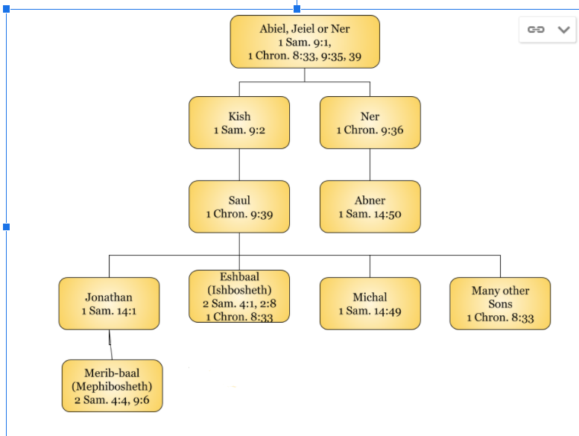

Appendix B - David’s Family Tree

Young David’s Family

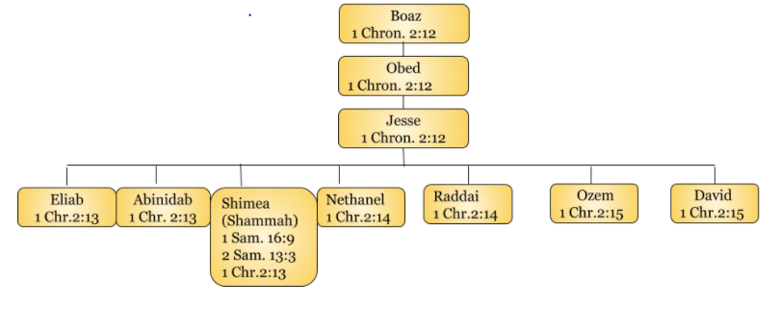

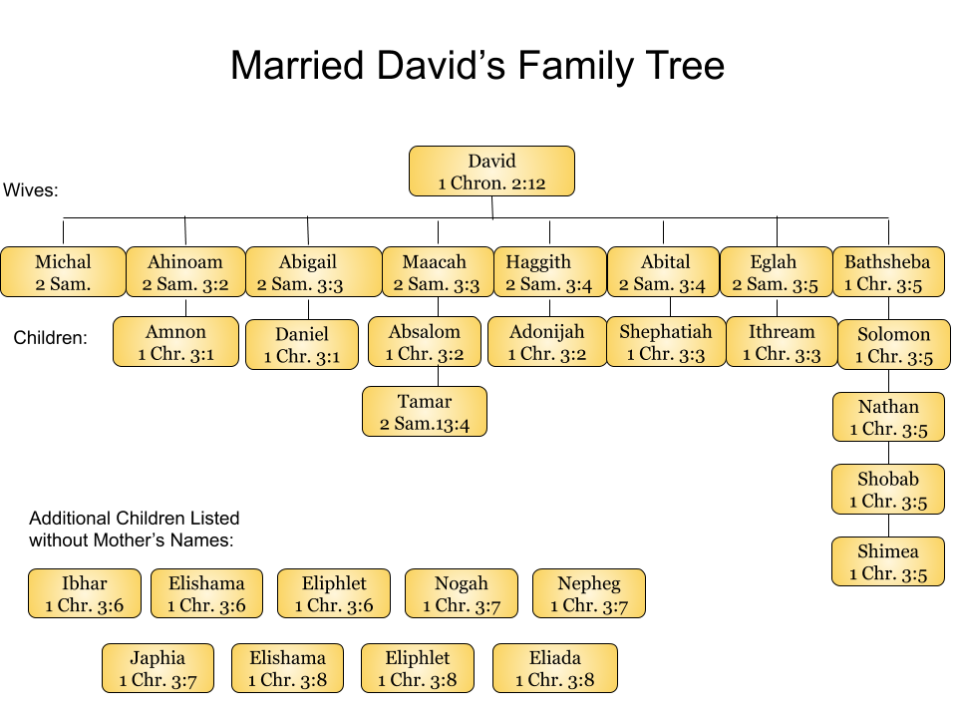

A suggested chart of the house of David by Steve Rudd

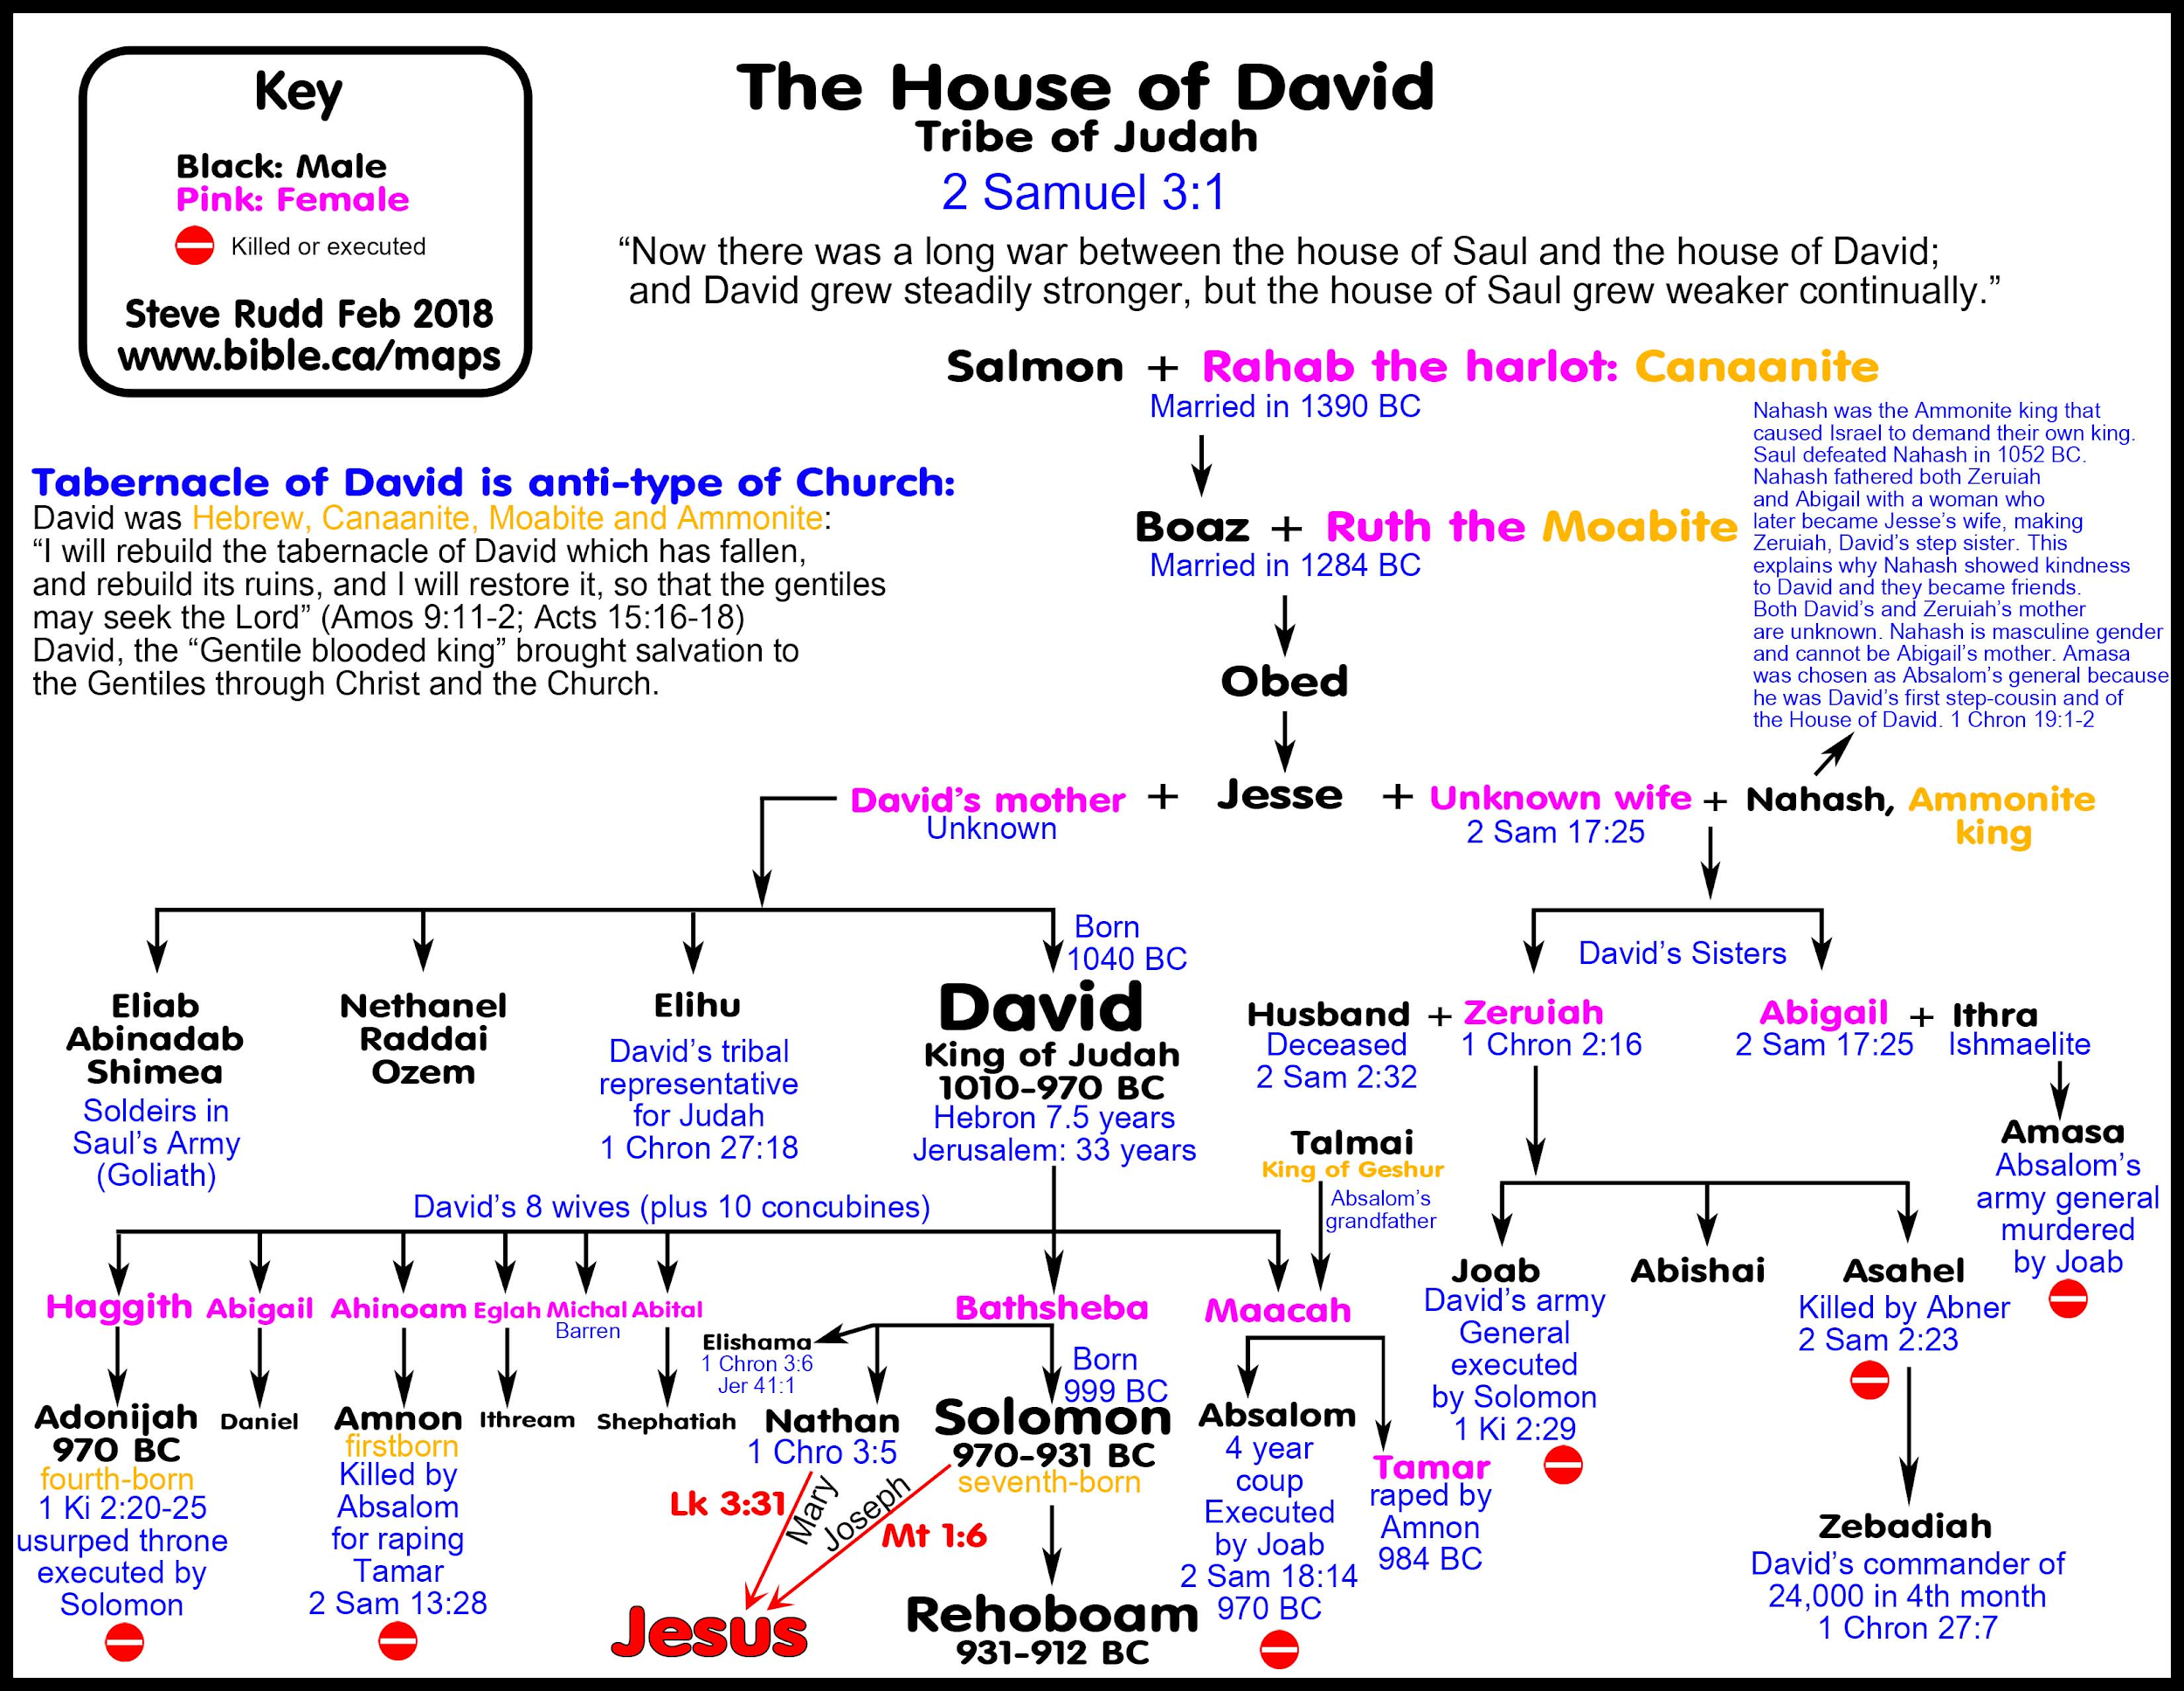

Appendix C - Maps of David’s Movements

Here are some blank maps in which you can mark the cities in the lessons:

Early Life of David ( Used with permission: downeyoldtestament.weebly.com)

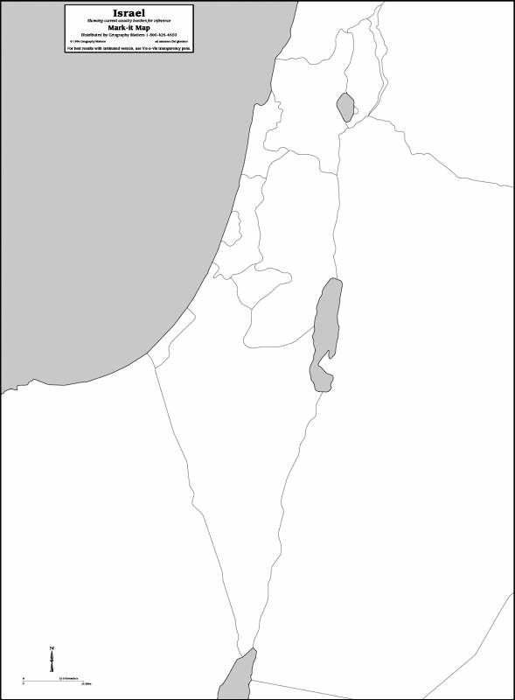

Bible-history.com

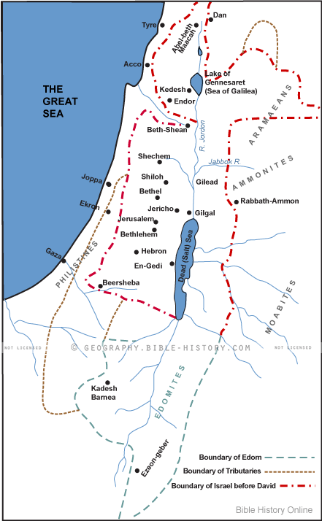
Bible-history.com

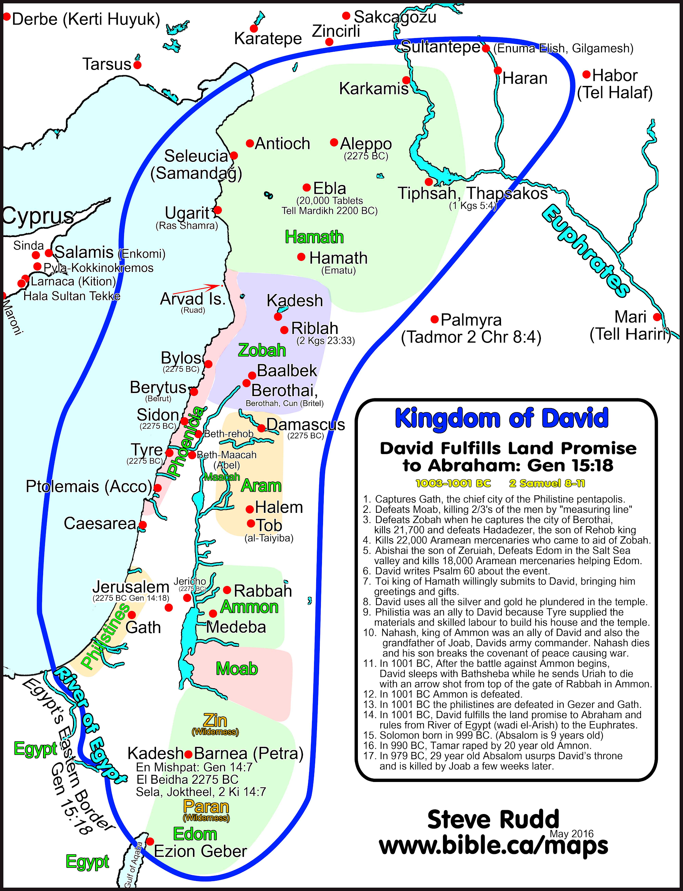
Appendix D - Character Reviews
- Saul _____ A) Born to Hannah in answer to prayer, dedicated to God. 1 Sam. 1:17
- Jesse _____ B) Saved husband’s life, later ridiculed him and became barren. 1 Sam. 19:12
- David _____ C) King of Gath, gives David refuge, then expels him. 1 Sam. 27:2
- Samuel _____ D) High Priest at Nob who served David showbread. 1 Sam. 21:1,6
- Goliath ______ E) Resourceful wife of Nabal who appeases David’s anger. 1 Sam. 25:23
- Jonathan _____ F) Michal’s second husband, grieved when David retrieves her. 1 Sam. 25:44
- Michal ______ G) Commander of David’s army, nephew of David killed Abner, Amasa. 2 Sam. 3:27
- Ahimelech _____ H) Brother of Abishai and Joab, nephew of David, captain of army. 1 Chr. 2:16

- Doeg _____ I) Tall man, hid among baggage, did not fully destroy the Amalekites. 1 Sam.10:22
- Achish ______ J) Name of wife of Saul and David (prob. not same)1 Sam.14:50, 1 Sam. 25:43

- Abiathar ______ K) Giant from Gath who challenged Israel. 1 Sam 17:8
- Nabal _____ L) Commander of Saul’s army and his cousin, slain by Joab. 1 Sam. 14:50
- Abigail _____ M) Saul’s son, became king for a short while, assassinated. 2 Sam. 2:8
- Ahinoam _____ N) Escaped from Nob, made high priest, served David loyally. 1 Sam. 22:20

- Palti _____ O) Edomite, chief of Saul’s herdsman, kills 85 priests. 1 Sam. 21:7

- Abner _____ P) David’s nephew, brother to Joab and Asahel, Co-commander. 1 Chr. 2:16
- Joab _____ Q) David’s son, forces himself on Tamar, killed by Absalom. 2 Sam. 13
- Abishai _____ R) Grandson of Ruth and Boaz. Ruth 4:17
- Ishbosheth _____ S) Wealthy, harsh sheep owner, first husband of Abigail. 1 Sam. 25:3
- Asahel _____ T) Saul’s eldest son, closest friend of David. 1 Sam. 14:49
- Amnon _____ U) Shepherd, Man after God’s own heart 1 Sam. 16:11, 1 Sam. 13:14

- Chileab _____ A) Called Jedidiah by Nathan, wise, many wives 2 Sam 12:25
- Absalom _____ B) Benjamite, insults David, executed by Solomon 2 Sam. 16:5
- Adonijah _____ C)Crippled son of Jonathan, David is kind to him. 2 Sam. 9:1
- Bathsheba _____ D) David’s gt.nephew, comm. of David and Abs. 2 Sam 17:25
- Uriah _____ E) A Benjamite insurrectionist, son of Bichri, 2 Sam. 20:1
- Solomon _____ F) Dtr. of David,Sister of Absalom,Forced by Amnon 2 Sam. 13

- Nathan _____ G) Saul’s eld. dtr, promised to David, given to Adriel. 1 Sam. 18:17
- Uzzah _____ H) Son of David & Haggith, desired Abishag as wife 1 Kgs 2:13
- Mephibosheth _____ I) Son of David & Maacah, hung by his hair in tree. 2 Sam 18:9
- Ziba _____ J) A Gileadite,provides David with beds & food, 2 Samuel 17:27
- Tamar _____ K) Saul’s concubine taken by Abner, her 5 sons killed. 2 Sam.
21:8-9
- Jonadab _____ L) Son of David and Abigail, also called Daniel 2 Sam. 3:3
- Zadok ____ M) A prophet, rebuked David’s sin. 2 Sam. 12:1
- Hushai _____ N) Saul’s servant, friend of David, accused by Mephibosheth
2 Sam. 19:17-30
- Ahithophel _____ O) Friend of David, defeats Ahithophel’s advice 2 Sam. 17:5-7
- Shimei _____ P)Son of Abinadab, struck; down for touching Ark. 2 Sam. 6:3
- Amasa _____ Q) Priest, loyal to David, anointed Solomon 1 Kg. 1:32-45
- Barzillai _____ R) A mighty man, Hittite, husband of Bathsheba 2 Sam 23:39
- Sheba _____ S) David’s nephew, Advises Amnon about Tamar 2 Sam.13:3
- Rizpah _____ T) Wife of Uriah, mother of Solomon, grand-daughter of
Ahithophel, deceived by Adonijah. 2 Sam 11:3, 2 Sam 23:34
- Merab ______ U) David’s counselor joins Absalom’s insurrection.2 Sam. 15:12

- Araunah _____ A) A Shunamite nurse of David, who kept him warm. 1 Kings 1:1
- Abishag _____ B) King of Tyre, David’s friend, sent supplies for Temple. 2 Sam. 5:11
- Hiram _____ C) Jebusite whose threshing floor was bought by David. 2 Sam 24:15-25

- Micah_____ D) Son of Mephibosheth 2 Sam. 9:12

- Abimelech ____ E) King of Zobah, Defeated by David in 2 Sam. 10:6; 2 Sam. 8:3

- Medium at Endor ___ F) Son of Abiathar, also called Ahimelech. 1 Chron. 18:16; 24:6

- Hanan ____ G) Commander of Syrian Army 2 Sam. 10:16

- Eleazar ____ H) Mighty Man, descendent of Jonathan, Benjamite. 1 Chron. 11:26

- Hadadezer ____ I) Mighty Man, Chief of the three mightiest, wielded a spear against
300 whom he killed at one time. 1 Chron. 11:11

- Shobach _____ J) Consulted by Saul and reluctantly conjured Samuel from dead.
2 Sam. 28:3

- Benaniah _____ K) Mighty Man, killed Philistines with David took a stand. 1 Chron. 11:12

54) Jashobeam_____ L) Mighty Man, struck down a lion in a pit on a snowy day and a tall
Egyptian. 1 Chron. 11:22

Appendix E: Timeline of David’s Life

Below are a few suggested chronological timelines of the events of David’s life, by Steve Rudd

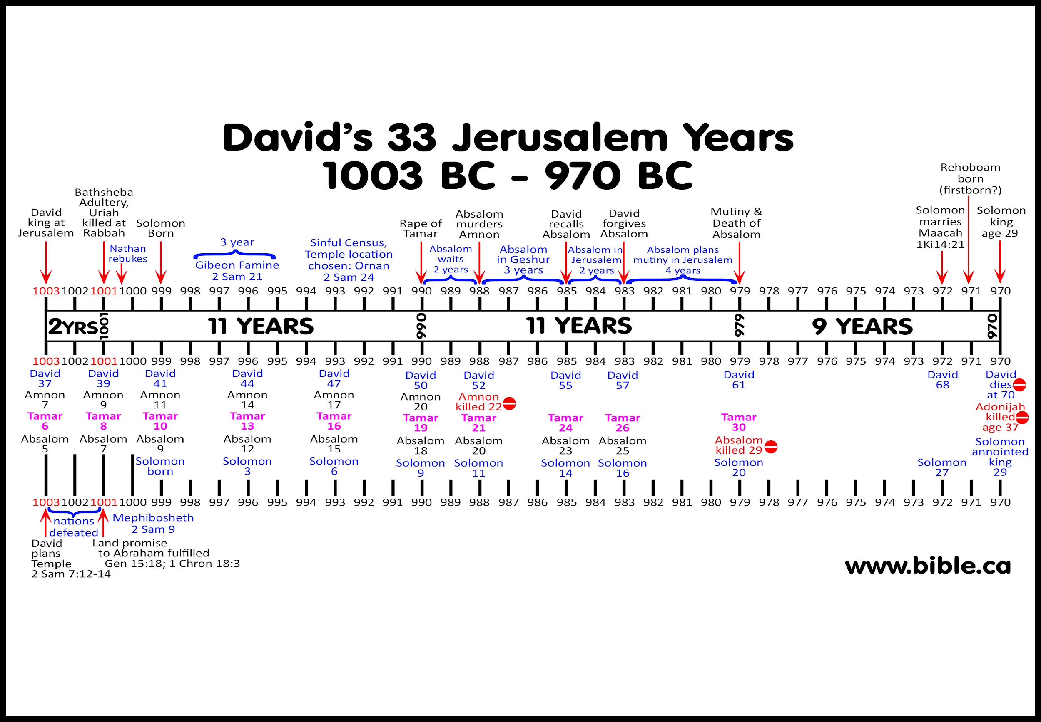

Appendix F - List of Other References to David in the Old Testament and New Testament

There are 1,141 results in 970 verses mentioned in the ESV.

Old Testament
David is mentioned and referenced after he passes in many chapters referring to David’s legacy, the house of David, the covenant God made with him, commandment of David, David the man of God, or the City of David.

Ruth 4:17, 4:22
1 Samuel Chapters 16-31
2 Samuel Chapters 1-24
1 Kings Chapters 1-2, referenced in 11 out of 22 total chapters in this book.
2 Kings referenced in 10/25 Chapters
1 Chronicles Chapters 11-29
2 Chronicles 27/36 Chapters reference David
Ezra 3:10, 8:2, 8:20
Nehemiah 3:15-16, 12:34,36

Psalms- It’s hard to tell how many David wrote, but some were attributed to him and possibly written by someone else. “Of” could mean David wrote it, or of could mean “about” David being the subject, “of” meaning inspired by David, supported by David.
Ps 23:6, 27:4, 36:8 reference the temple after David died - these are called Anachronistic (as opposed to Chronological- in order) because they are out of place in time.

Le Dawid - belonged to a group of songs that belonged to the Temple - a Royal psalm
In contrast to the ones to the Sons of Korah. Interpret them as unknowable, because we don’t know for sure which ones. 1 Sam 16:14, David a musician, but we don’t have him referenced Mark 12:35-37, Acts 2:?

“Psalms of David” Total of 73 Attributing David as a Title.
Ps. 3-9, 11-32, 34-41, 51-65, 68-70, 86, 101, 103, 108-110, 122, 124, 131, 133, 138-145.
Ps. 18:50 is the first one that mentions David in the actual Psalm, “not as a Title”
72:20, Prayers of David
78:70, Chose David His Servant
89:3,20,35, 49 *
122:5 Thrones of the House of David
132:1, 10, 11, 17
144:10

Proverbs 1:1
Eccl. 1:1
Song of Songs 4:4
Isaiah 7:2, 13, 9:7, 16:5, 22:9, 22, 29:1, 37:35, 38:5, 55:3
Jeremiah 13:13, 17:25, 21:12, 22:2,4,30, 23:5, 29:16, 30:9, 33:15, 33:17, 33:21, 33:22, 33:26, 36:30.
Ezekiel 34:23,24, 37:24,25
Hosea 3:5
Amos 6:5, 9:11
Zechariah 12:7,8,10,12, 13:1

New Testament
Matthew 1:1, 6, 17, 20, 22, 9:27, 12:3, 23, 15:22, 20:30,31, 21:9,15, 22:42, 43, 45
Mark 2:25, 10:47,48, 11:10, 12:35-37
Luke 1:27, 32, 69, 2:4, 11, 3:31, 6:3, 18:38-39, 20:41, 42, 44
John 7:42
Acts 1:16, 2:25, 2:29, 2:34, 4:25, 7:45, 13:22, 34,36, 15:16
Romans 1:3, 4:6, 11:9
2 Corinthians 6:18
2 Timothy 2:8
Hebrews 1:5,8-13, 4:7, 11:32
Revelation 3:7, 5:5, 22:16

Bibliography

Arnold, Bill T. 1 And 2 Samuel: The NIV Application Commentary from Biblical Text-- to Contemporary Life. Zondervan, 2003.
Boda, Mark J. After God's Own Heart: the Gospel According to David. P & R Pub., 2007.
Gordon, R. P. I & II Samuel: A Commentary. Paternoster, 1986.
Japhet, Sara. I & II Chronicles: A Commentary. Westminster John Knox Press, 1993.
Klein, Ralph W. 2 Chronicles: A Commentary. Fortress Press, 2006.
Longman , Tremper, and David E Garland. The Expositor's Bible Commentary Revised Edition 1 Samuel - 2 Kings. Zondervan, 2009.
McKenzie, Steven L. 1-2 Chronicles. Abingdon Press, 2004.
Provan, Iain W. 1 & 2 Kings. Baker Books, 1995.
Tsumura, David Toshio. The Second Book of Samuel. William B. Eerdmans Publishing Company, 2019.

